EXERCISE
“HTML”

PROGRAMMING
COSMOS
OF

(EX-1)
Write the code of an application which describes the header code in html(Like h1 to h6).

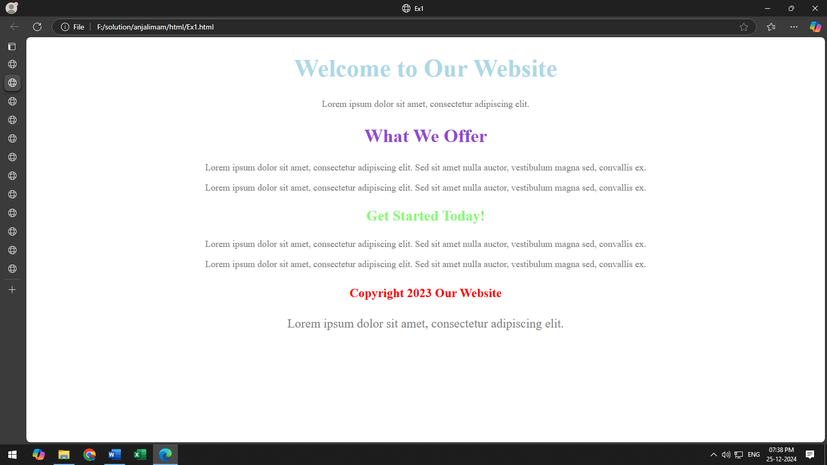
(Ex-2)
Write the code of an application which describes the header code in html.(Use diff.tags).

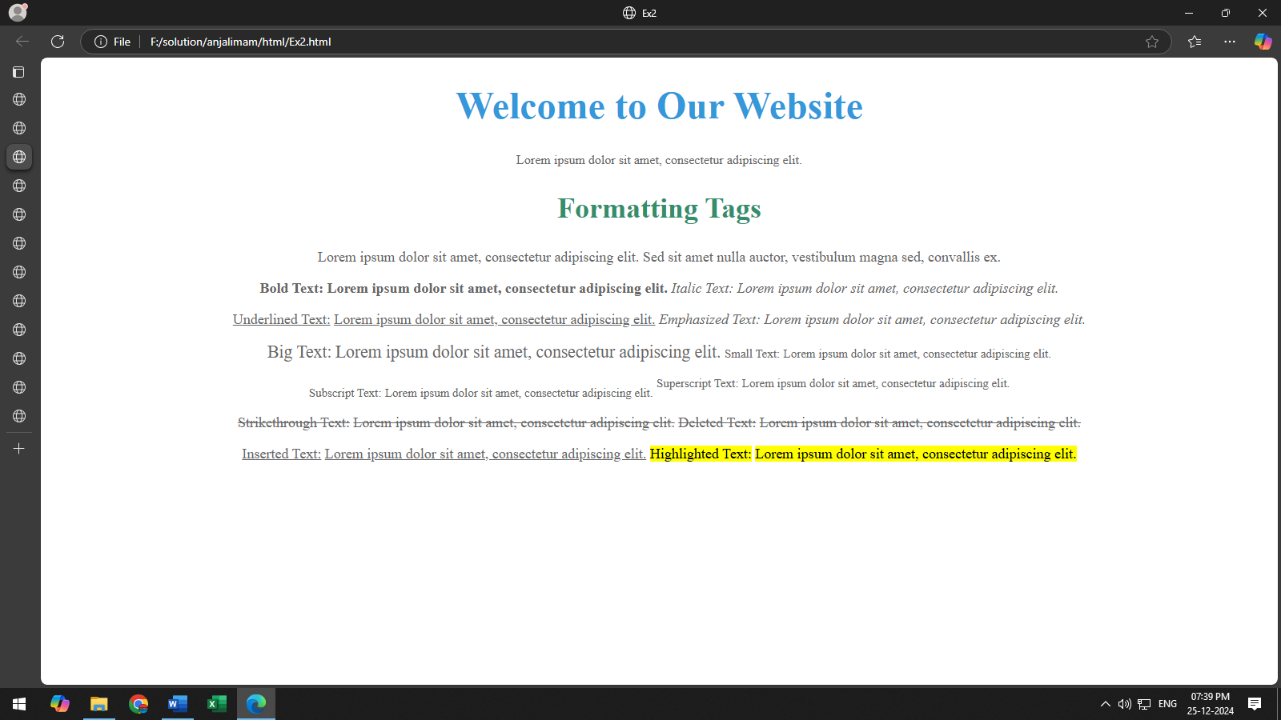
(Ex-3)
Write the code of an application which describes the header code in html.

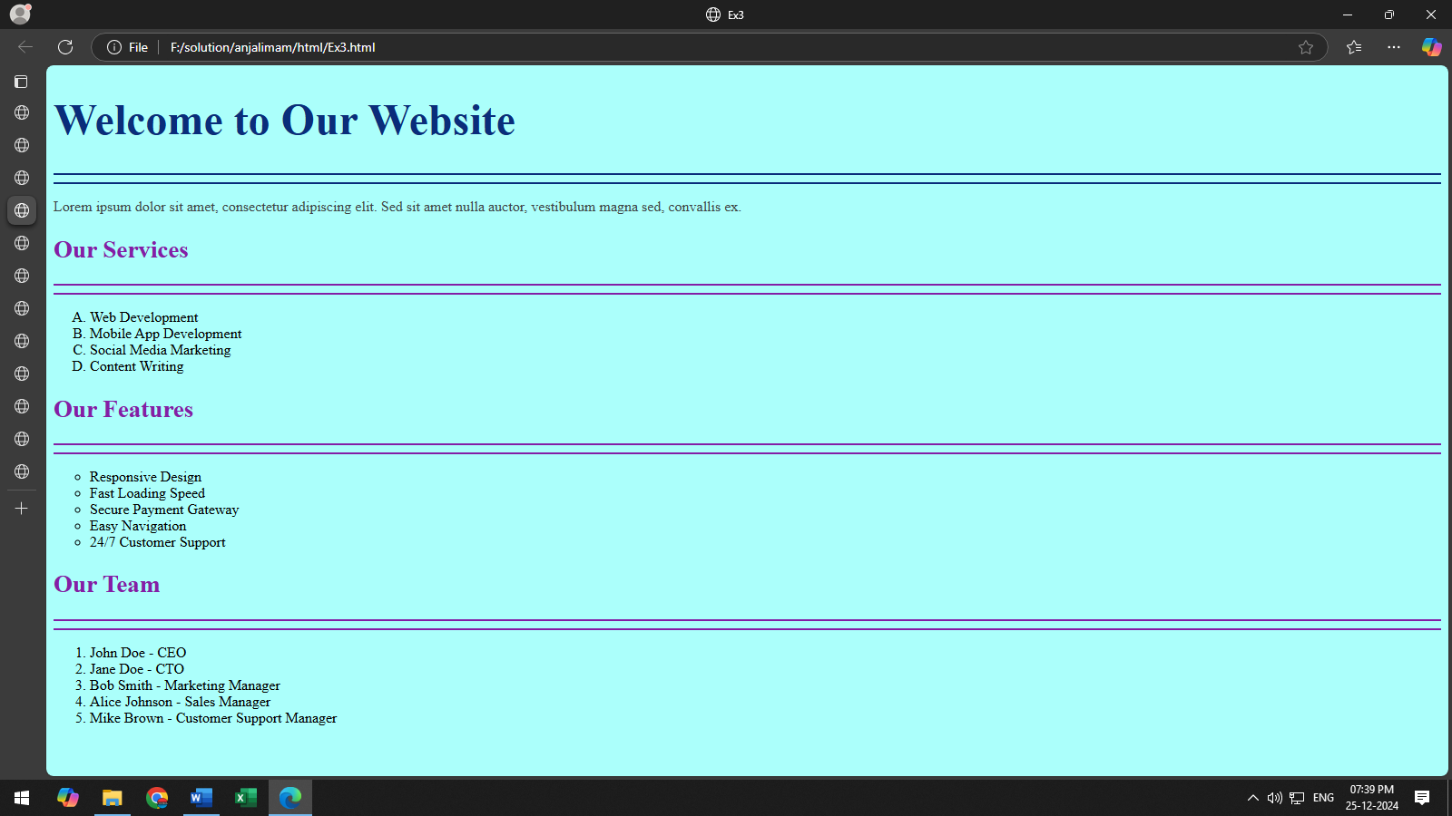

(Ex-4)
Write the code of an application which describes the header code in html.

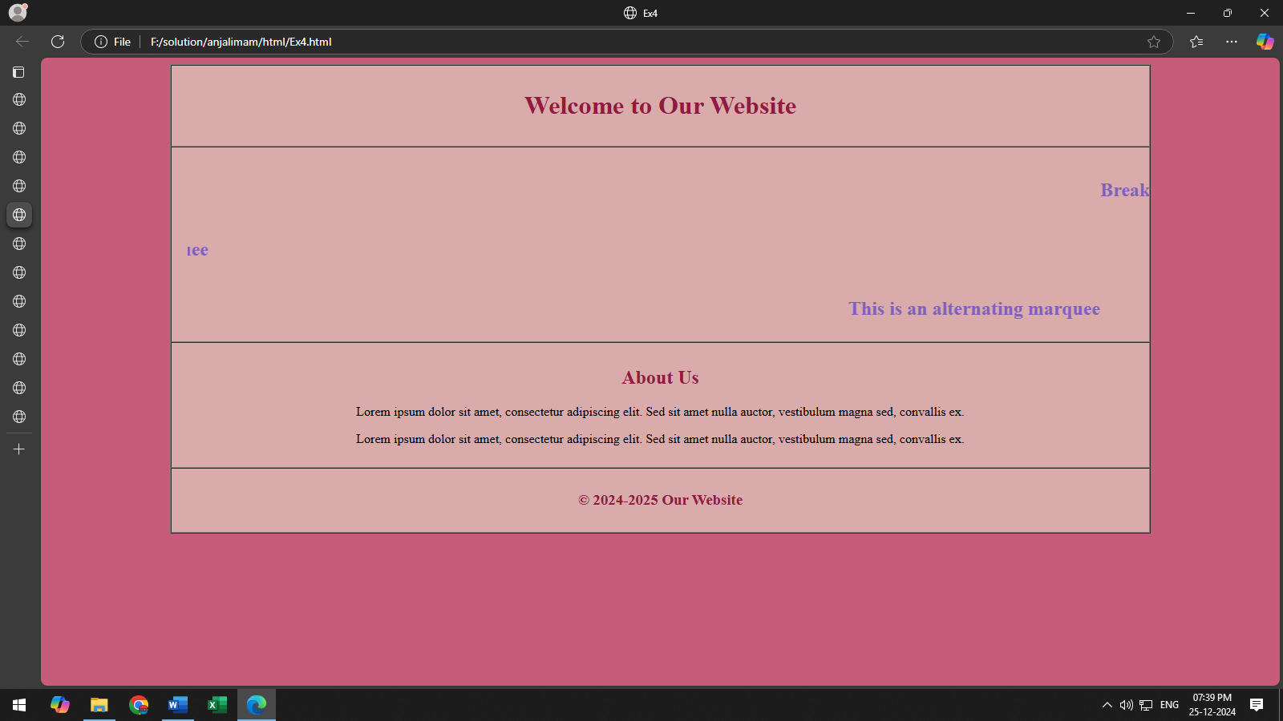

(Ex-5)
Write the code of an application which describes the header code in html.

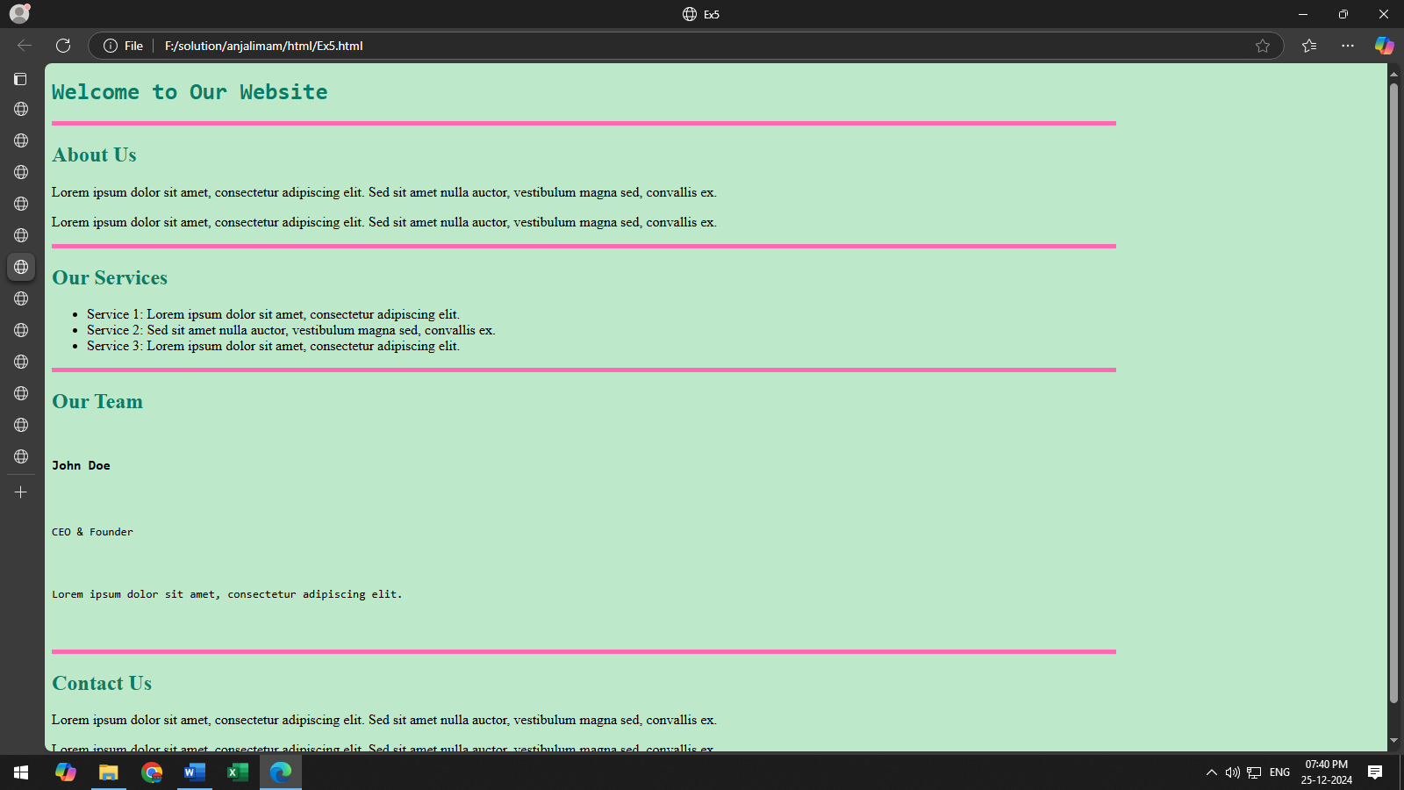

(Ex-6)
Write the code of an application which describes the header code in html.

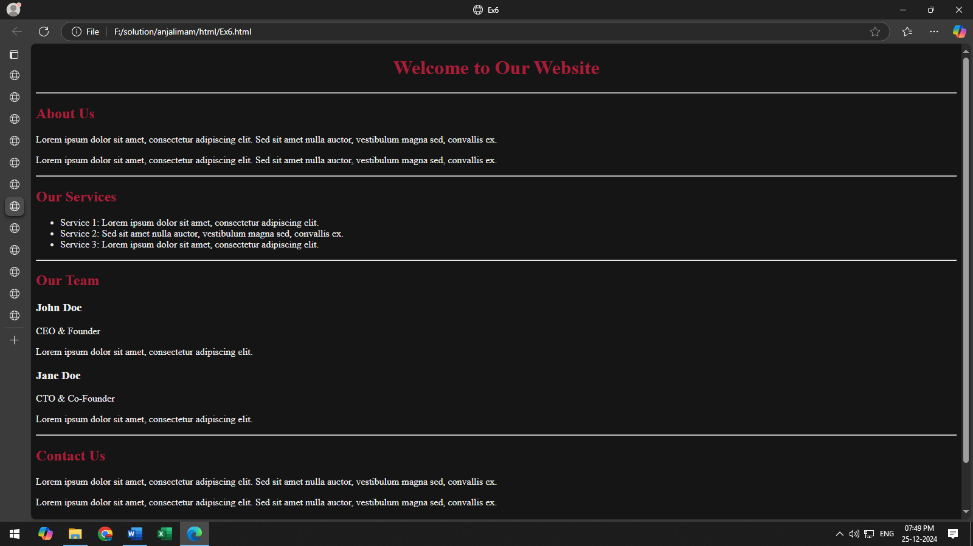

(Ex-7)
Write the code of an application which describes the header code in html.

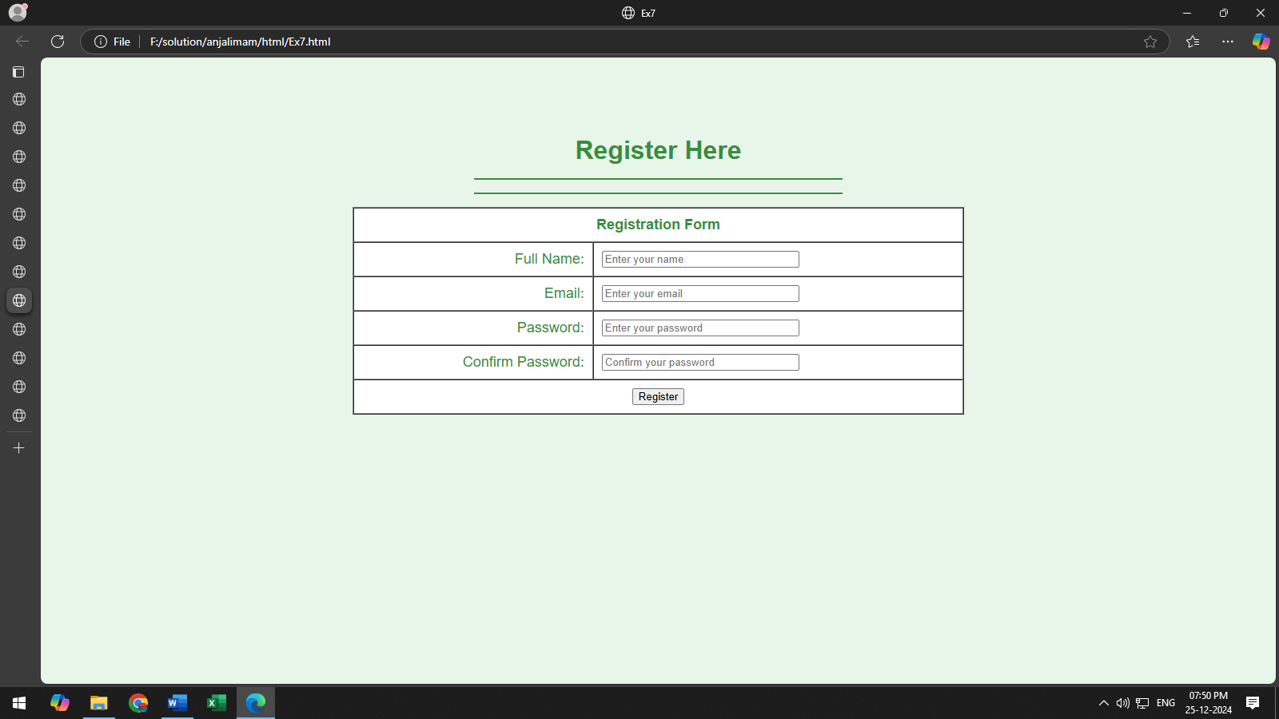

(Ex-8)
Write the code of an application which describes the header code in html.

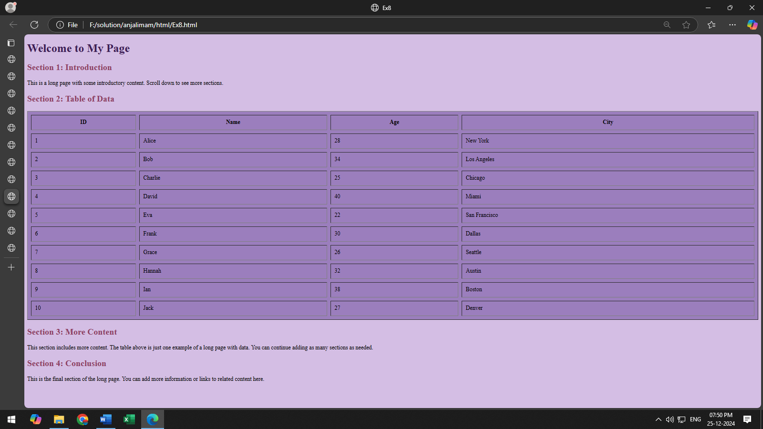

(Ex-9)
Write the code of an application which describes the header code in html.

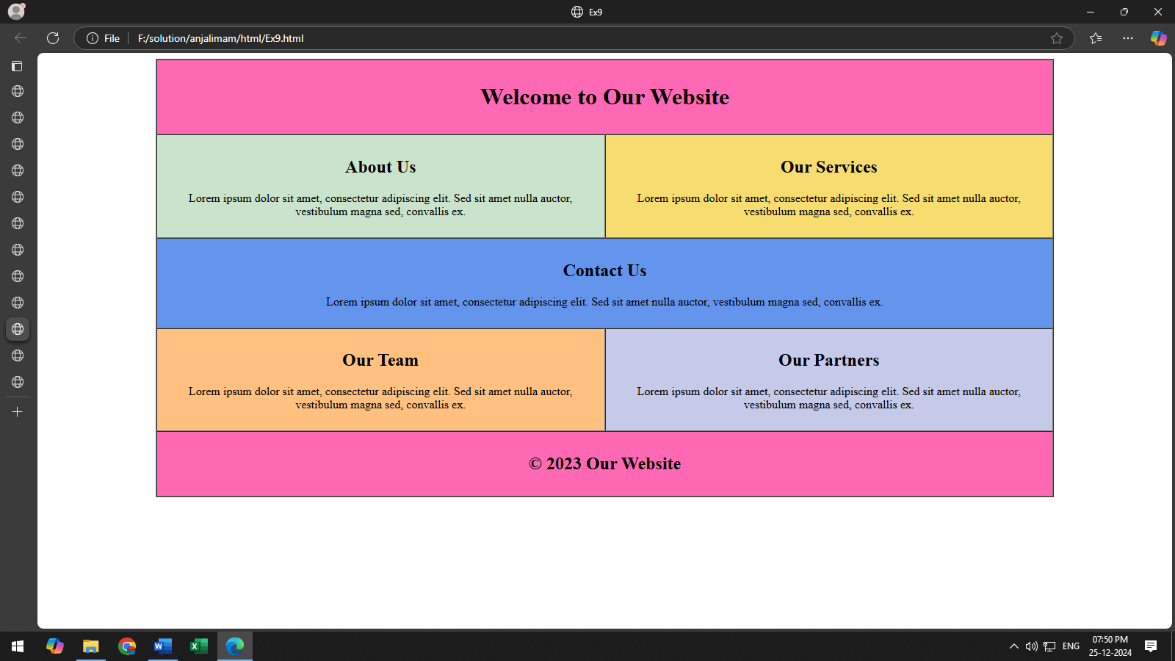

(Ex-10)
Write the code of an application which describes the header code in html.

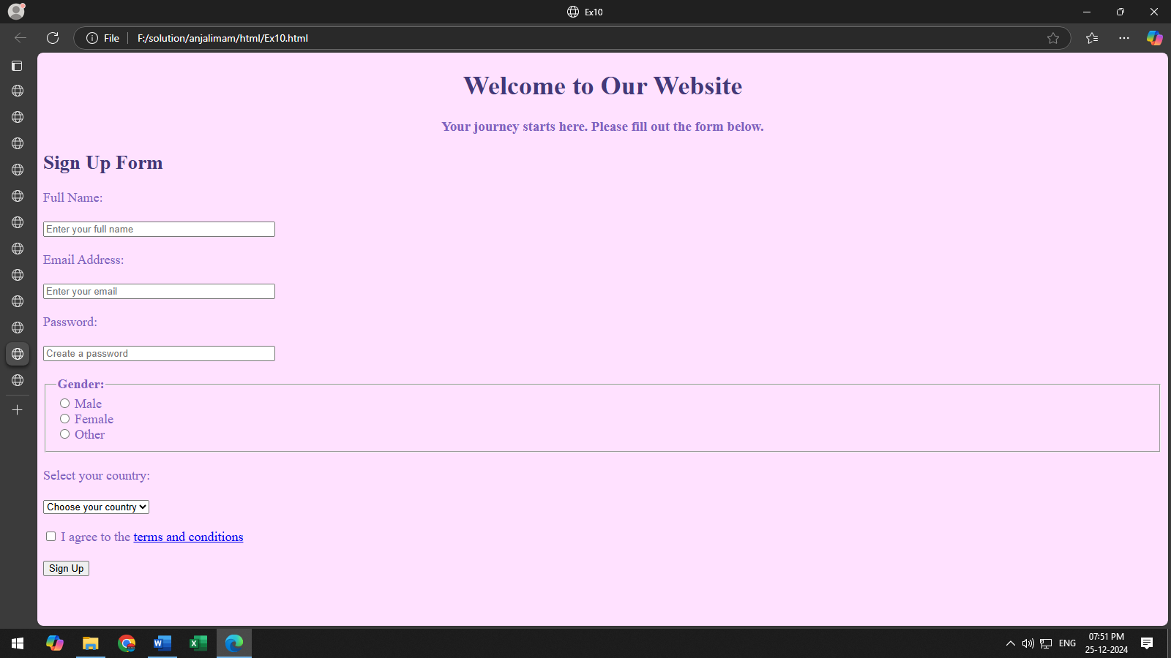

(Ex-11)
Write the code of an application which describes the header code in html.

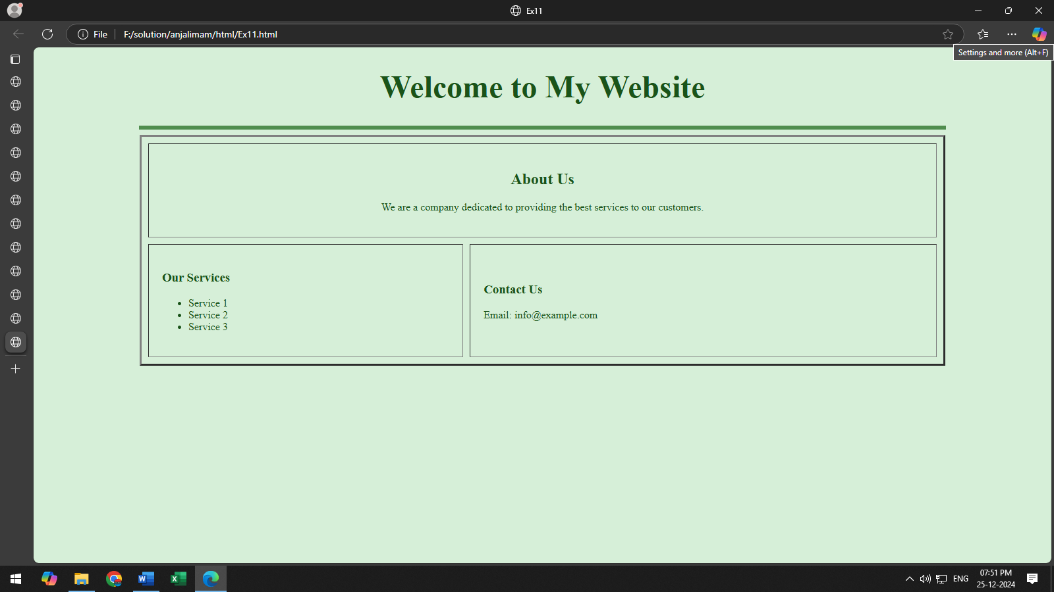

(Ex-12)
Write the code of an application which describes the header code in html.

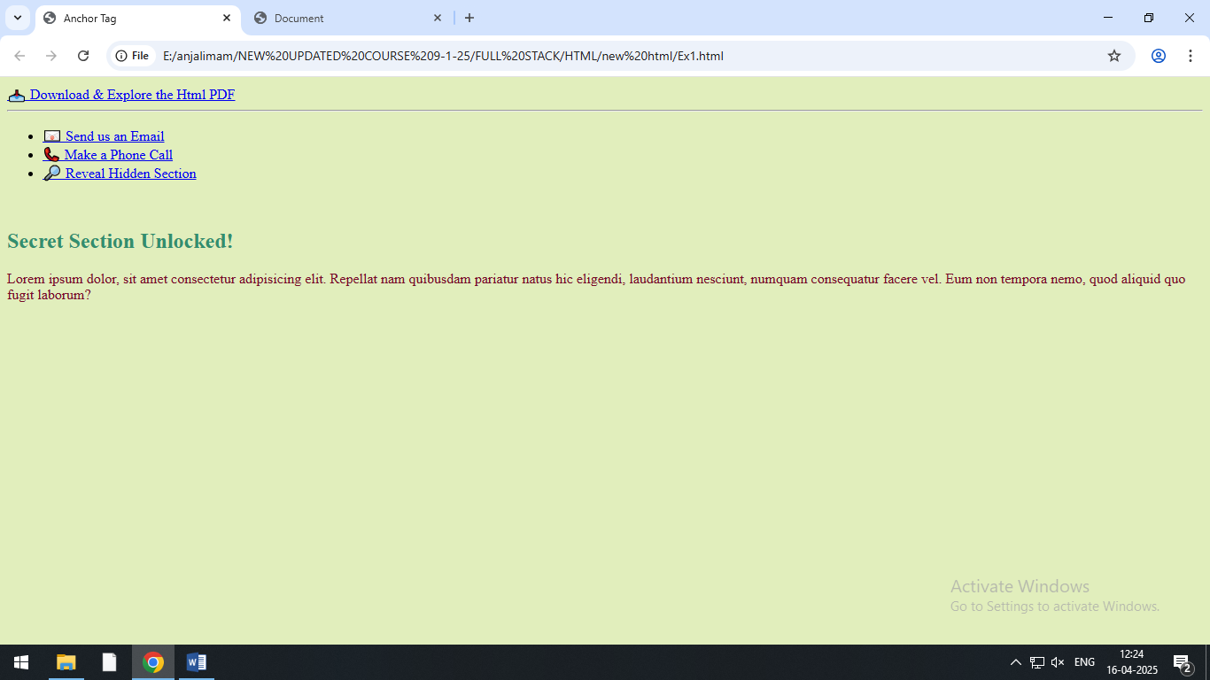

(Ex-13)
Write the code of an application which describes the header code in html.
